CREATE TABLE ResourceTbl

(ResNo VARCHAR2(8) CONSTRAINT ResNoNotNull NOT NULL,

ResName VARCHAR2(30) CONSTRAINT ResNameNotNull NOT NULL,

Rate NUMBER(8,2) CONSTRAINT RateNotNull NOT NULL,

CONSTRAINT PK_ResourceTbl PRIMARY KEY (ResNo) ) ;

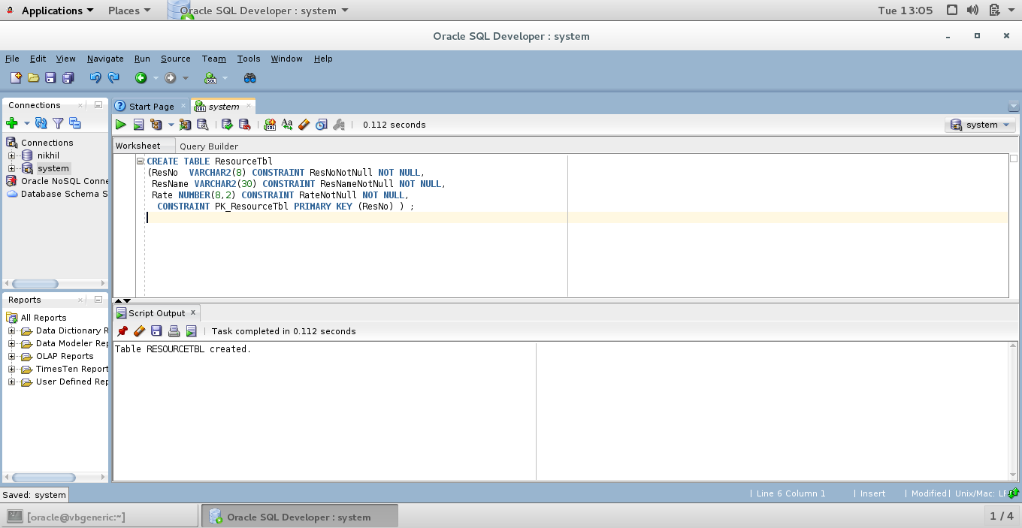

COLUMN Rate FORMAT $99999990.99;

Select * from resourcetbl;

